**SKIN DISEASE PREDICTION**

**INTRODUCTION**

Skin disease Is a major problem among people worldwide. Different machine learning techniques can be applied to identify classes of skin diseases using ensemble techniques, and then a feature selection method is utilized to compare the results obtained.

**CASE STUDY**

**RWANDA BIOMEDICAL CENTRE**

Rwanda Biomedical Centre (RBC) is the nation’s health implementation agency. RBC was established in 2011 through a merger of fourteen key health Institutions. RBC strives to improve the health of the Rwandan population by providing high quality and sustainability health care service. This is accomplished through the implementation of preventative, rehabilitative, and curate health interventions.

**MISSION**

RBC promotes high quality, affordable, and sustainable health care service to the population through evidence-based interventions and practices guided by ethics and professionalism.

**VISION**

To become a Center of Excellence for the prosperity of the country, ensuring quality health service, education and research.

**SKIN DISEASE PREDICTION-AS IS PROCESS MODEL**

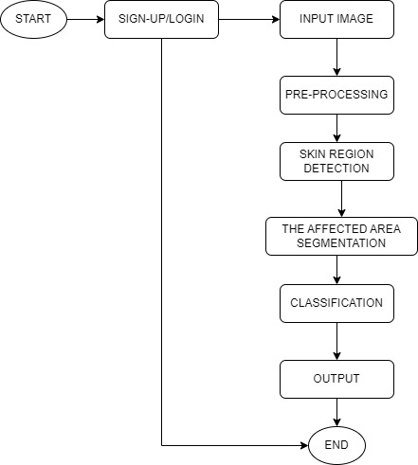

**PROBLEMS WITH THE CURRENT SYSTEM**

* **Performance**
* **Throughput**
* Some hospitals are not able to identify correctly the type of skin disease the patient has.
* Some people neglect to go for checking because of thinking it is just any easy disease it is going to disappear soon.
* It takes people long time to go to hospital for checking skin disease.
* It cost people much money to go to hospital for checking.
* **Response Time**
* **I**t takes time the person to know how long they spend at the hospital.
* It takes time the people to know where they can found the specialist in skin disease.
* **Information**
* **Input**
* Normally people take time to go to the doctor at the hospital, pick a number, and then wait in line for various departments to be treated by doctors and receive the service they have been waiting for.
* **Output**
* Some patients fail to wait and leave without meeting the doctor.
* Some patient prefers to use traditional action thinking it will help them
* **Storage**
* Thepatient list is kept in the files at reception office.
* **Economics**
* Thecurrent system cost the patient the time to seat at the hospital waiting for the service.
* The current system cost the people money for transport to go to hospital.
* **Controls**
* It is hard for patient to continue being isolated at hospital if he sick contaminated disease.
* It is hard for patient to continue keeping the paper number for the service.
* It is hard for the receptionist to make the patients follow the number on the paper correctly.
* **Efficiency**
* The current system is not efficient to the: patients, receptionist and doctors
* **Service**
* Many patients feel bored for the system because of arriving early and spend much time there waiting for service.